Implementing Complex Agregation

Step 1: Calculate Basic Aggregations
Query:
SELECT
SUM(quantity) AS total_quantity,
ROUND(AVG(unit_price), 2) AS average_unit_price,
SUM(quantity * unit_price) AS total_revenue
FROM sales;

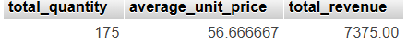
Output:

_____________________________________________________________________________________________________

Step 2: Group Sales by Region

Query:
SELECT
region,
SUM(quantity * unit_price) AS total_revenue
FROM sales
GROUP BY region;

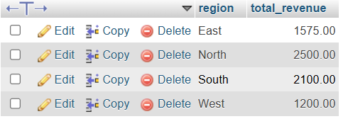
Output:

_______________________________________________________________________________________________________
Step 3: Group Sales by Region and Product
Query:
SELECT
region,
product_id,
SUM(quantity * unit_price) AS total_revenue
FROM sales
GROUP BY region, product_id
ORDER BY region, product_id;

Output:
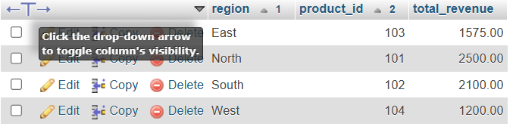

_______________________________________________________________________________________________________
Step 4: Calculate Running Total of Revenue by Region
Query:
SELECT
sale_date,
region,
ROUND(SUM(quantity * unit_price), 2) AS daily_revenue,
ROUND(
SUM(SUM(quantity * unit_price)) OVER (
PARTITION BY region
ORDER BY sale_date
ROWS UNBOUNDED PRECEDING
), 2
) AS running_total_revenue
FROM sales
GROUP BY sale_date, region
ORDER BY region, sale_date;

Output:
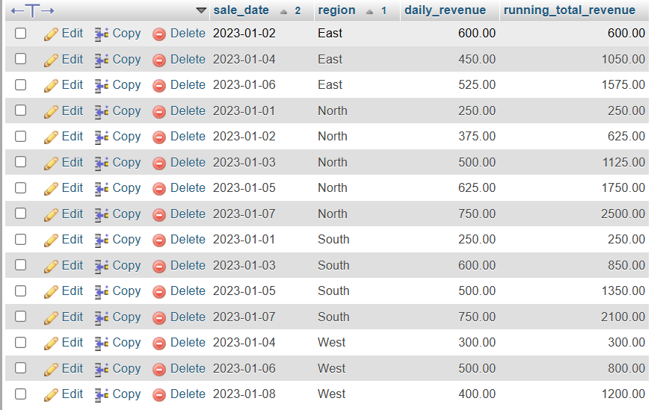

_______________________________________________________________________________________________________
Step 5: Calculate Moving Average of Revenue
Query:
SELECT
sale_date,
region,
ROUND(SUM(quantity * unit_price), 2) AS daily_revenue,
ROUND(
AVG(SUM(quantity * unit_price)) OVER (
PARTITION BY region
ORDER BY sale_date
ROWS BETWEEN 2 PRECEDING AND CURRENT ROW
), 2
) AS moving_avg_3day
FROM sales
GROUP BY sale_date, region
ORDER BY region, sale_date;

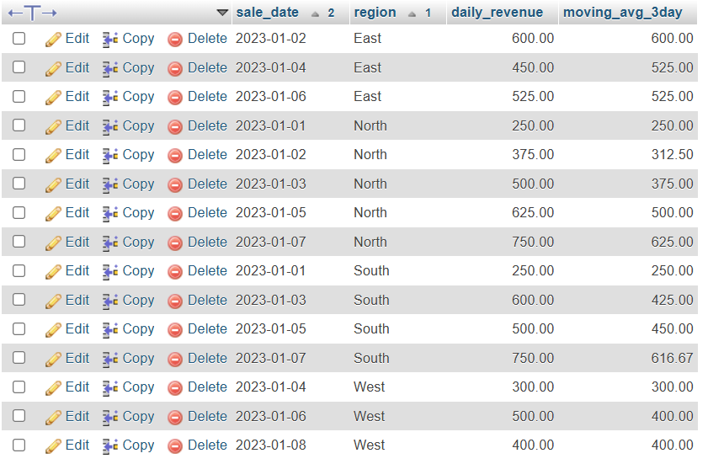
Output:

______________________________________________________________________________________________________

